**DECCAN COLLEGE OF ENGINEERING AND TECHNOLOGY**

**(AFFILIATED TO OSMANIA UNIVERSITY, HYDERABAD)**

**DEPARTMENT OF INFORMATION TECHNOLOGY**



**A Internship report on**

**Virtual clinic using hospital management system**

**Submitted for the internship of B. E VI Sem (CBCS)**

**BY**

**MOHD ABDUL KHADER-160320737019**

**FAHAD KHAN-160320737013**

**MOHAMMED SHAARE UDDIN-160320737032**

**DECCAN COLLEGE OF ENGINEERING AND TECHNOLOGY**

**(AFFILIATED TO OSMANIA UNIVERSITY, HYDERABAD)**

**DEPARTMENT OF INFORMATION TECHNOLOGY**

**A Internship report on**

**Virtual clinic using hospital management system**

**Submitted for the internship of B. E VI Sem (CBCS)**

**BY**

**SK KARIM HASHMI-160317737005**

**TANWI MAHABOOB-160317737007**

**SHAIK SHAMRAN-160317737016**



DECCAN COLLEGE OF ENGINEERING AND TECHNOLOGY

**Dar-us-Salam, Hyderabad - 500 001.**



**DEPARTMENT OF INFORMATION TECHNOLOGY**

**SUMMER INTERNSHIP**

|  |
| --- |
| **CERTIFICATE** |
| This is to certify that **MOHD ABDUL KHADER (160320737019), FAHAD KHAN(160320737013), MOHAMMED SHAARE UDDIN (160320737032)** of B.E.VII  Semester, **INFORMATION TECHNOLOGY** branch has successfully completed the  **SUMMER INTERNSHIP** work during the academic year **2023 - 2024.** |
| Summer Internship  Co-ordinator Internal Guide HOD External Examiner |

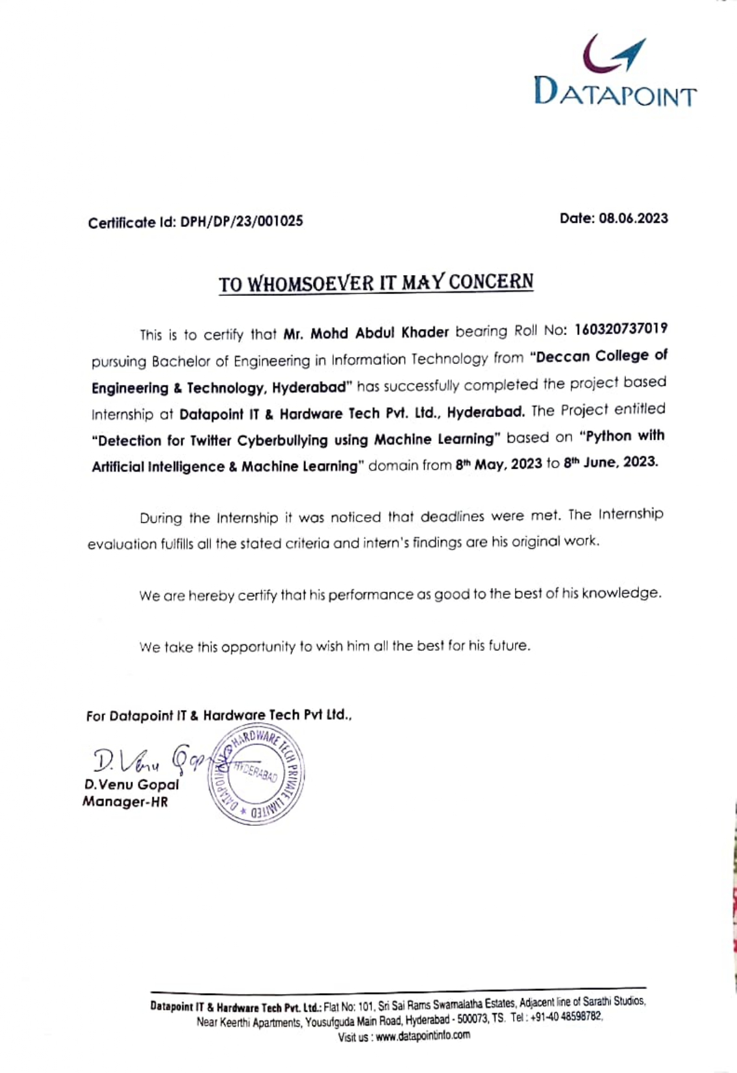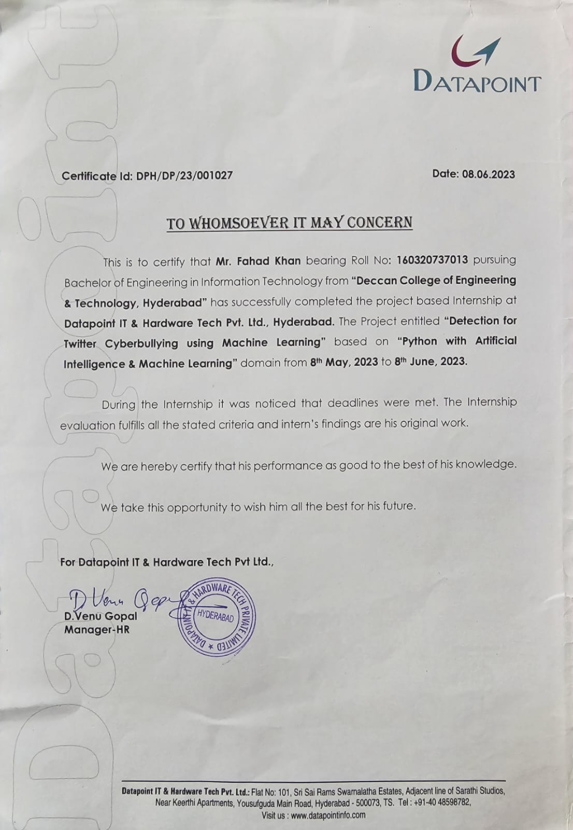

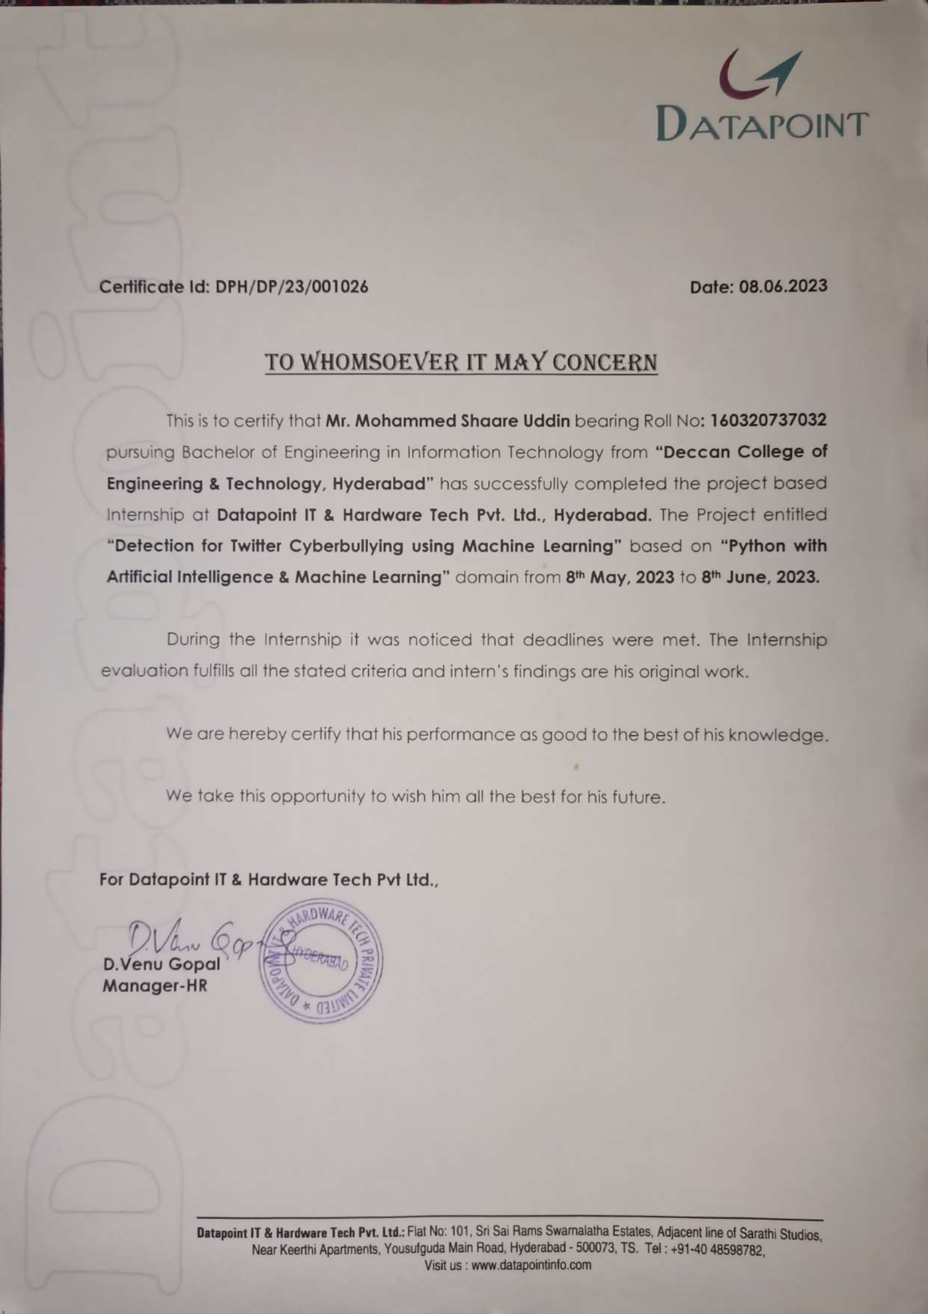

**DECLARATION**

This is to certify that the work reported in the present project entitled “**TWITTER CYBERBULLYING SYSTEM”** is a record of work done by us in the Department of Information Technology, Deccan College of Engineering and Technology, Osmania University. The reports are based on the project work done entirely by us and not copied from any other source.

**MOHD ABDUL KHADER-160320737019**

**FAHAD KHAN-160320737013**

**MOHAMMED SHAARE UDDIN-160320737032**

vi

**A C K N O W L E D G E M E N T**

I would like to express my sincere gratitude and indebtedness to my project supervisor **Mrs Reshma mam.**

Finally, I would like to take this opportunity to thanks my family for their support through the work. I sincerely acknowledge and thanks who gave directly or indirectly

their support in this internship work.

**MOHD ABDUL KHADER-160320737019**

**FAHAD KHAN-160320737013**

**MOHAMMED SHAARE UDDIN-160320737032**

**MACHINE LEARNING BASED TWITTER CYBERBULLYING SYSTEM**

**ABSTRACT:**

Social media is a platform where many young people are getting bullied. As social networking sites are increasing, cyberbullying is increasing day by day. To identify word similarities in the tweets made by bullies and make use of machine learning and can develop an ML model automatically detect social media bullying actions. However, many social media bullying detection techniques have been implemented, but many of them were textual based. The goal of this paper is to show the implementation of software that will detect bullied tweets, posts, etc. A machine learning model is proposed to detect and prevent bullying on Twitter. Two classifiers i.e. SVM and Naïve Bayes are used for training and testing the social media bullying content. Both Naive Bayes and SVM (Support Vector Machine) were able to detect the true positives with 71.25% and 52.70% accuracy respectively. But SVM outperforms Naive Bayes of similar work on the same dataset. Also, Twitter API is used to fetch tweets and tweets are passed to the model to detect whether the tweets are bullying or not.

**TABLE OF CONTENTS**

Certificate…………………………………………………………………………………. i

Declaration……………………………………………………………………………….... ii

Acknowledgements…………………………………………………………………………iii

Abstract……………………………………………………………………………….…...iv

**CHAPTER I**

INTRODUCTION

**CHAPTER II**

LITERATURE SURVEY

**CHAPTER III**

SYSTEM ANALYSIS

3.1 Objectives………………………………………………………………….

3.2 Problem Specification…………………………………………………….

3.3 Proposed System………………………………………………………….

3.4 Applications……………………………………………………………….

3.5 Modules and their functionalities……………………………………….

3.6 Software and Hardware requirements………………………………….

**CHAPTER IV**

DESIGN

4.2 Flow charts…………………………………………………………….

4.3 Algorithms…………………………………………………………

**CHAPTER V**

IMPLEMENTATION

5.1 Source code………………………………………………………...

5.2 Screenshots………………………………………………………...

**CHAPTER VI**

CONCLUSION AND FUTURE ENHANCEMENT

6.1 Conclusion……………………………………………………….

**CHAPTER 1: INTRODUCTION**

Nowadays technology has become a very important part of our lives and most people can't live without it. The Internet provides a platform to share their ideas. Many people are spending a large amount of time on social media. Communicating with people is no exception, as technology has changed the way people interact with a broader manner and has given a new dimension to communication. Many people are illegally using these communities. Many youngsters are getting bullied these days. Bullies use various services like Twitter, Facebook, Email to bully people. Studies show that about 37% of children in India are involved in cyberbullying and nearly 14% of bullying occurs regularly. Cyberbullying affects the victim both ways emotionally and psychologically. Social media also allows bullies to harness the anonymity which satisfies their unkind deeds. Things also get more serious when bullying occurs more repeatedly over time. So, preventing it from happening will help the victim.

CHAPTER 2:LITERATURE SURVEY

# 1)" “Social Media Cyberbullying Detection using Machine Learning”,

# AUTHORS: John Hani Mounir, Mohamed Nashaat, Mostafa Ahmed, Zeyad Emad, Eslam Amer, Ammar Mohammed,

# —With the exponential increase of social media users, cyberbullying has been emerged as a form of bullying through electronic messages. Social networks provides a rich environment for bullies to uses these networks as vulnerable to attacks against victims. Given the consequences of cyberbullying on victims, it is necessary to find suitable actions to detect and prevent it. Machine learning can be helpful to detect language patterns of the bullies and hence can generate a model to automatically detect cyberbullying actions. This paper proposes a supervised machine learning approach for detecting and preventing cyberbullying. Several classifiers are used to train and recognize bullying actions. The evaluation of the proposed approach on cyberbullying dataset shows that Neural Network performs better and achieves accuracy of 92.8% and SVM achieves 90.3. Also, NN outperforms other classifiers of similar work on the same dataset.

# 2"Using Machine Learning to Detect Cyberbullying,"

# AUTHORS: Kelly Reynolds, April Kontostathis, Lynne Edwards

# Cyber bullying is the use of technology as a medium to bully someone. Although it has been an issue for many years, the recognition of its impact on young people has recently increased. Social networking sites provide a fertile medium for bullies, and teens and young adults who use these sites are vulnerable to attacks. Through machine learning, we can detect language patterns used by bullies and their victims, and develop rules to automatically detect cyber bullying content. The data we used for our project was collected from the website Formspring.me, a question-and-answer formatted website that contains a high percentage of bullying content. The data was labeled using a web service, Amazon's Mechanical Turk. We used the labeled data, in conjunction with machine learning techniques provided by the Weka tool kit, to train a computer to recognize bullying content. Both a C4.5 decision tree learner and an instance-based learner were able to identify the true positives with 78.5% accuracy.

# 3 ""Content-based Cybercrime Detection,"

# AUTHORS: Amanpreet Singh, Maninder Kaur

# In recent years, content-based cybercrime detection has become a topic of attraction among researchers. Cybercrime has emerged as a money-driven industry with malicious intent towards online social networks. Cyber-criminals aim to manipulate vulnerable areas in cyberspace by playing on human understanding and making a profit. They threaten minors, especially adolescents, who are not adequately overseen while online. To address this issue, there is an urgent need for a robust content-based cybercrime detection framework. The aim of this research work is to explore possible combinations of various preprocessing, feature selection and classification methodologies using the cuckoo search metaheuristic approach. This approach seeks to improve the performance of content-based cybercrime detection system. For the purpose of this research, four publicly available datasets for cyberbullying detection have been utilized for evaluating the effectiveness of the proposed algorithm. The algorithm was then further compared with three recent cyberbullying detection models based on various evaluation parameters. These parameters included precision, recall and f-measure. The experimental results demonstrate the effectiveness of the proposed approach. This approach outperformed other recent techniques on all the datasets, giving high predictive recall value via tenfold cross-validation.

**4 " "Social media bullying detection using machine learning on Bangla text”,**

**AUTHORS: Abdhullah-Al-Mamun, Shahin Akhter**

with the popularity of Unicode system and growing use of Internet, the use of Bangla over social media is increasing. However, very few works have been done on Bangla text for social media activity monitoring due to a lack of a large number of annotated corpora, named dictionaries and morphological analyzer, which demands in-depth analysis on Bangladesh's perspective. Moreover, solving the issue by applying available techniques is very content specific, which means that false detection can occur if contents changed from formal English to verbal abuse or sarcasm. Also, performance may vary due to linguistic differences between English and non-English contents and the socio-emotional behaviour of the study population. To combat such issues, this paper proposes the use of machine learning algorithms and the inclusion of user information for cyber bullying detection on Bangla text. For this purpose, a set of Bangla text has been collected from available social media platforms and labelled as either bullied or not bullied for training different machine learning based classification models. Cross-validation results of the models indicate that a support vector machine based algorithm achieves superior performance on Bangla text with a detection accuracy of 97%. Besides, the impact of user specific information such as location, age and gender can further improve the classification accuracy of Bangla cyber bullying detection system.

5) **“Cyberbullying detectionusing time series modeling**

**AUTHORS**: **NektariaPotha and ManolisMaragoudakis.**

Cyber bullying is a new phenomenon resulting from the advance of new communication technologies including the Internet, cell phones and Personal Digital Assistants. It is a challenging bullying problem occurring in a new territory. Online bullying can be particularly damaging and upsetting because it's usually anonymous or hard to trace. In this paper, the proposed method is utilizing a dataset of real world conversations (i.e. Pairs of questions and answers between cyber predator and the victim), in which each predator question is manually annotated in terms of severity using a numeric label. We approach the issue as a sequential data modelling approach, in which the predator's questions are formulated using a Singular Value Decomposition representation. The motivation of this procedure is to study the accuracy of predicting the level of cyber bullying attack using classification methods and also to examine potential patterns between the lingustic style of each predator. More specifically, unlike previous approaches that consider a fixed window of a cyber-predator's questions within a dialogue, we exploit the whole question set and model it as a signal, whose magnitude depends on the degree of bullying content. Using feature weighting and dimensionality reduction techniques, each signal is straightforwardly parsed by a neural network that forecasts the level of insult within a question given a window between two and three previous questions. Throughout the time series modeling experiments, an interesting discovery was made. By applying SVD on the time series data and taking into account the second dimension (since the first is usually modeling trivial dependencies between instances and attributes) we observed that its plot was very similar to the plot of the class attribute. By applying a Dynamic Time Warping algorithm, the similarity of the aforementioned signals was proved to exist, providing an immediate indicator for the severity of cyber bullying within a give...

**CHAPTER 3:SYSTEM ANALYSIS**

**EXISTING SYSTEM:**

Cyber bullying is the use of technology as a medium to bully someone. Although it has been an issue for many years, the recognition of its impact on young people has recently increased. Social networking sites provide a fertile medium for bullies, and teens and young adults who use these sites are vulnerable to attacks. Through machine learning, we can detect language patterns used by bullies and their victims, and develop rules to automatically detect cyber bullying content.

**DISADVANTAGES OF EXISTING SYSTEM:**

* Hence the results of producing with such kind of results are not satisfying.
* Datasets are not sufficient to predict better results.

**Algorithms:** KNN.

**PROPOSED SYSTEM:**

In this paper, a solution is proposed to detect twitter cyberbullying. The main difference with previous research is that we not only developed a machine learning model to detect cyberbullying content but also implemented it on particular locations real-time tweets using Twitter API. The entire approach to detect and prevent Twitter cyberbullying is divided into 2 major stages: developing the model and experimental setup. The Natural Language Toolkit (NLTK) is used for the preprocessing of data. NLTK is used for tokenization of text patterns, to remove stop words from the text, etc. The entire model is divided into 3 major steps: Preprocessing, the algorithm, and feature extraction. The first step in the solution is to collect the tweets from Twitter using

Twitter API. In the next two steps are data preprocessing and feature extraction is performed over the tweets. And after performing preprocessing and feature extraction tweets are passed to the SVM model for classification to predict whether the tweet is Bullying or Non-Bullying. The second step In this step, the proposed model has transformed the data in a suitable form which is passed to the machine learning algorithms. The TFDIF vectorizer [1] is used to extract the features of the given data. Features of the data are extracted and put them in a list of features. Also, the polarity (i.e. the text is Bullying or Non-Bullying) of each text is extracted and stored in the list of features. The third step To detect social media bullying automatically, supervised Binary classification machine learning algorithms like SVM with linear kernel and Naive Bayes is used. The reason behind this is both SVM and Naive Bayes calculate the probabilities for each class (i.e. probabilities of Bullying and Non-Bullying tweets). Both SVM and NB algorithms are used for the classification of the two-cluster.

**ADVANTAGES OF PROPOSED SYSTEM:**

* Naive Bayes models are used recommendation systems, sentiment analysis, and spam filtering. Naive Bayes algorithms are very easy to implement.
* SVM and Naive Bayes are evaluated to calculate the accuracy, recall, f-score, and precision. Interestingly SVM outperformed Naive Bayes in every aspect.

**Algorithms:** machine learning; classifiers; Naive Bayes; support vector machine (SVM); Twitter API.

**MODULES:**

* User
* Admin
* Data Preprocessing
* Machine Learning

**MODULES DESCRIPTION:**

**User:**

The User can register first. While registering he required a valid user email and mobile for further communications. Once the user register then admin can activate the user. Once admin activated the user then user can login into our system. User can upload the dataset based on our dataset column matched. For algorithm execution data must be in int or float format. Here we took   
Adacel Technologies Limited dataset for testing purpose. User can also add the new data for existing dataset based on our Django application. User can click the Data Preparations in the web page so that the data cleaning process will be starts. The cleaned data and its required graph will be displayed.

**Admin:**

Admin can login with his login details. Admin can activate the registered users. Once he activate then only the user can login into our system. Admin can view Users and he can view overall data in the browser and he load the data. Admin can view the training data list and test data list. Admin can load the data and view forecast results.

**SYSTEM STUDY**

**FEASIBILITY STUDY**

The feasibility of the project is analyzed in this phase and business proposal is put forth with a very general plan for the project and some cost estimates. During system analysis the feasibility study of the proposed system is to be carried out. This is to ensure that the proposed system is not a burden to the company. For feasibility analysis, some understanding of the major requirements for the system is essential.

**Three key considerations involved in the feasibility analysis are,**

* **ECONOMICAL FEASIBILITY**
* **TECHNICAL FEASIBILITY**
* **SOCIAL FEASIBILITY**

**ECONOMICAL FEASIBILITY**

This study is carried out to check the economic impact that the system will have on the organization. The amount of fund that the company can pour into the research and development of the system is limited. The expenditures must be justified. Thus the developed system as well within the budget and this was achieved because most of the technologies used are freely available. Only the customized products had to be purchased.

### TECHNICAL FEASIBILITY

This study is carried out to check the technical feasibility, that is, the technical requirements of the system. Any system developed must not have a high demand on the available technical resources. This will lead to high demands on the available technical resources. This will lead to high demands being placed on the client. The developed system must have a modest requirement, as only minimal or null changes are required for implementing this system.

**SOCIAL FEASIBILITY**

The aspect of study is to check the level of acceptance of the system by the user. This includes the process of training the user to use the system efficiently. The user must not feel threatened by the system, instead must accept it as a necessity. The level of acceptance by the users solely depends on the methods that are employed to educate the user about the system and to make him familiar with it. His level of confidence must be raised so that he is also able to make some constructive criticism, which is welcomed, as he is the final user of the system.

**SYSTEM SPECIFICATION:**

**HARDWARE REQUIREMENTS:**

* **System :** Intel i3
* **Hard Disk :** 1 TB.
* **Monitor** : 14’ Colour Monitor.
* **Mouse :** Optical Mouse.
* **Ram :** 4GB.

**SOFTWARE REQUIREMENTS:**

* **Operating system :** Windows 10.
* **Coding Language :** Python.
* **Front-End :** Html. CSS
* **Designing :** Html,css,javascript.
* **Data Base :** SQLite.

**Chapter 4:DESIGN**

**SYSTEM ARCHITECTURE:**

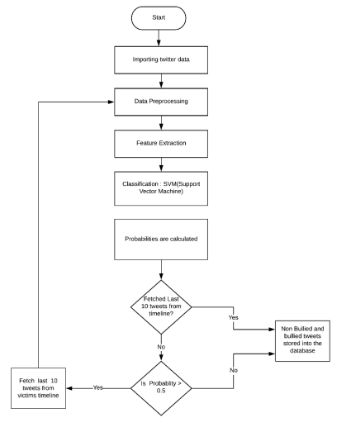

**DATA FLOW DIAGRAM:**

1. The DFD is also called as bubble chart. It is a simple graphical formalism that can be used to represent a system in terms of input data to the system, various processing carried out on this data, and the output data is generated by this system.
2. The data flow diagram (DFD) is one of the most important modeling tools. It is used to model the system components. These components are the system process, the data used by the process, an external entity that interacts with the system and the information flows in the system.
3. DFD shows how the information moves through the system and how it is modified by a series of transformations. It is a graphical technique that depicts information flow and the transformations that are applied as data moves from input to output.
4. DFD is also known as bubble chart. A DFD may be used to represent a system at any level of abstraction. DFD may be partitioned into levels that represent increasing information flow and functional detail.

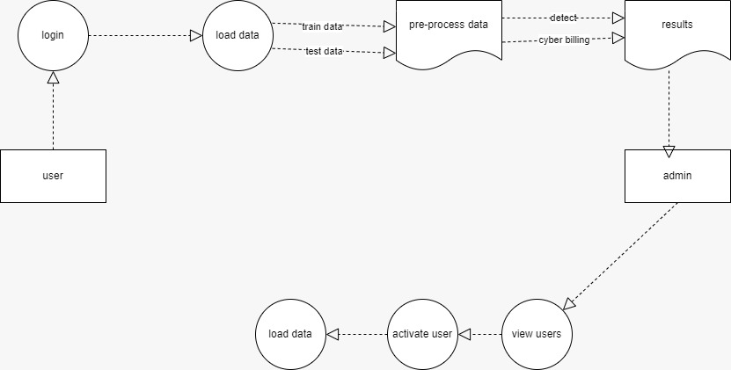

**UML DIAGRAMS**

UML stands for Unified Modeling Language. UML is a standardized general-purpose modeling language in the field of object-oriented software engineering. The standard is managed, and was created by, the Object Management Group.

The goal is for UML to become a common language for creating models of object oriented computer software. In its current form UML is comprised of two major components: a Meta-model and a notation. In the future, some form of method or process may also be added to; or associated with, UML.

The Unified Modeling Language is a standard language for specifying, Visualization, Constructing and documenting the artifacts of software system, as well as for business modeling and other non-software systems.

The UML represents a collection of best engineering practices that have proven successful in the modeling of large and complex systems.

The UML is a very important part of developing objects oriented software and the software development process. The UML uses mostly graphical notations to express the design of software projects.

**GOALS:**

The Primary goals in the design of the UML are as follows:

1. Provide users a ready-to-use, expressive visual modeling Language so that they can develop and exchange meaningful models.
2. Provide extendibility and specialization mechanisms to extend the core concepts.
3. Be independent of particular programming languages and development process.
4. Provide a formal basis for understanding the modeling language.
5. Encourage the growth of OO tools market.
6. Support higher level development concepts such as collaborations, frameworks, patterns and components.
7. Integrate best practices.

**USE CASE DIAGRAM:**

A use case diagram in the Unified Modeling Language (UML) is a type of behavioral diagram defined by and created from a Use-case analysis. Its purpose is to present a graphical overview of the functionality provided by a system in terms of actors, their goals (represented as use cases), and any dependencies between those use cases. The main purpose of a use case diagram is to show what system functions are performed for which actor. Roles of the actors in the system can be depicted.

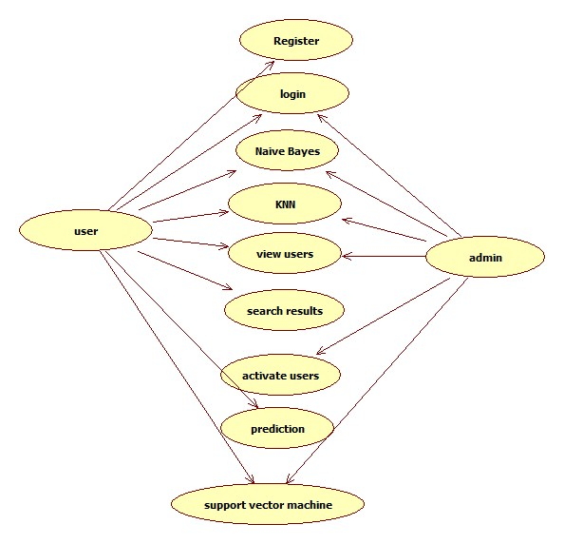

**CLASS DIAGRAM:**

In software engineering, a class diagram in the Unified Modeling Language (UML) is a type of static structure diagram that describes the structure of a system by showing the system's classes, their attributes, operations (or methods), and the relationships among the classes. It explains which class contains information.

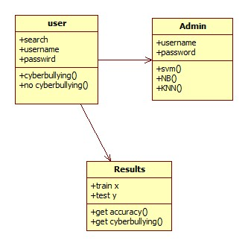

**SEQUENCE DIAGRAM:**

A sequence diagram in Unified Modeling Language (UML) is a kind of interaction diagram that shows how processes operate with one another and in what order. It is a construct of a Message Sequence Chart. Sequence diagrams are sometimes called event diagrams, event scenarios, and timing diagrams.

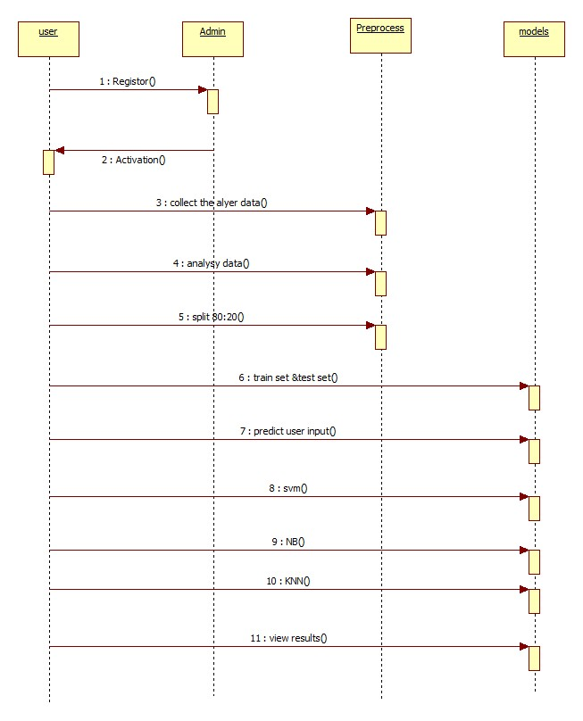

**ACTIVITY DIAGRAM:**

Activity diagrams are graphical representations of workflows of stepwise activities and actions with support for choice, iteration and concurrency. In the Unified Modeling Language, activity diagrams can be used to describe the business and operational step-by-step workflows of components in a system. An activity diagram shows the overall flow of control.

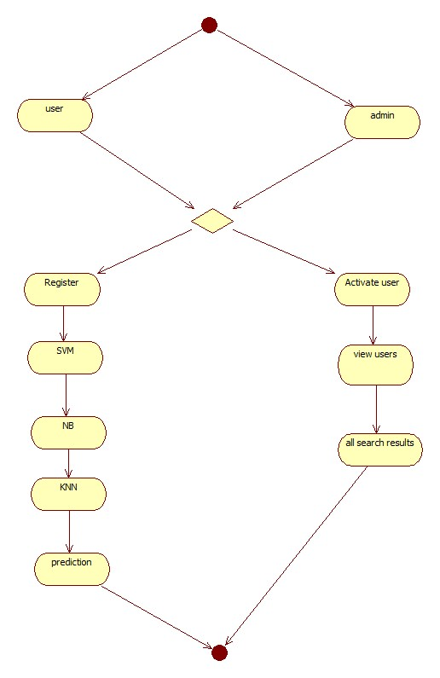

**CHAPTER 5:IMPLEMENTATION**

**User side views:**

from ast import alias

from concurrent.futures import process

from django.shortcuts import render

# Create your views here.

from django.shortcuts import render, HttpResponse

from django.contrib import messages

import twitter

from .forms import UserRegistrationForm

from .models import UserRegistrationModel

from django.conf import settings

import pandas as pd

# Create your views here.

def UserRegisterActions(request):

if request.method == 'POST':

form = UserRegistrationForm(request.POST)

if form.is_valid():

print('Data is Valid')

form.save()

messages.success(request, 'You have been successfully registered')

form = UserRegistrationForm()

return render(request, 'UserRegistrations.html', {'form': form})

else:

messages.success(request, 'Email or Mobile Already Existed')

print("Invalid form")

else:

form = UserRegistrationForm()

return render(request, 'UserRegistrations.html', {'form': form})

def UserLoginCheck(request):

if request.method == "POST":

loginid = request.POST.get('loginid')

pswd = request.POST.get('pswd')

print("Login ID = ", loginid, ' Password = ', pswd)

try:

check = UserRegistrationModel.objects.get(

loginid=loginid, password=pswd)

status = check.status

print('Status is = ', status)

if status == "activated":

request.session['id'] = check.id

request.session['loggeduser'] = check.name

request.session['loginid'] = loginid

request.session['email'] = check.email

print("User id At", check.id, status)

return render(request, 'users/UserHomePage.html', {})

else:

messages.success(request, 'Your Account Not at activated')

return render(request, 'UserLogin.html')

except Exception as e:

print('Exception is ', str(e))

pass

messages.success(request, 'Invalid Login id and password')

return render(request, 'UserLogin.html', {})

def UserHome(request):

return render(request, 'users/UserHomePage.html', {})

def DatasetView(request):

path = settings.MEDIA_ROOT + "//" + 'twitter.csv'

df = pd.read_csv(path, nrows=100)

df = df.to_html

return render(request, 'users/viewdataset.html', {'data': df})

def usrtwitterFNDML(request):

from .utility import twitterMLEDA

svm_acc, svm_report = twitterMLEDA.process_SVM()

svm_report = pd.DataFrame(svm_report).transpose()

svm_report = pd.DataFrame(svm_report)

nb_acc, nb_report = twitterMLEDA.process_naiveBayes()

nb_report = pd.DataFrame(nb_report).transpose()

nb_report = pd.DataFrame(nb_report)

return render(request, 'users/twitterMl.html',

{

'svm_report': svm_report.to_html, 'svm_acc': svm_acc,

'nb_report': nb_report.to_html, 'nb_acc': nb_ac })

def predictTrustWorthy(request):

if request.method == 'POST':

test_user_data = request.POST.get('news')

print(test_user_data)

from .utility import twitterMLEDA

result = twitterMLEDA.fake_news_det(test_user_data)

return render(request, 'users/testform.html', {'msg': result})

else:

return render(request, 'users/testform.html', {})

**Base.html**

{% load static %}

<!DOCTYPE html>

<html lang="en">

<head>

<meta charset="utf-8">

<title>Detecting A Twitter Cyberbullying Using Machine Learning</title>

<meta content="width=device-width, initial-scale=1.0" name="viewport">

<meta content="Free Website Template" name="keywords">

<meta content="Free Website Template" name="description">

<link href="{% static 'img/favicon.ico' %}" rel="icon">

<link href="https://fonts.googleapis.com/css2?family=Open+Sans:wght@300;400;600;700;800&display=swap" rel="stylesheet">

<link href="https://stackpath.bootstrapcdn.com/bootstrap/4.4.1/css/bootstrap.min.css" rel="stylesheet">

<link href="https://cdnjs.cloudflare.com/ajax/libs/font-awesome/5.10.0/css/all.min.css" rel="stylesheet">

<link href="{% static 'lib/animate/animate.min.css' %}" rel="stylesheet">

<link href="{% static 'lib/owlcarousel/owl.carousel.min.css' %}" rel="stylesheet">

<link href="{% static 'lib/lightbox/css/lightbox.min.css' %}" rel="stylesheet">

<link href="{% static 'css/style.css' %}" rel="stylesheet">

</head>

<body>

<div class=" navbar navbar-expand-lg bg-dark navbar-dark ">

<div class="container-fluid">

<a href="index.html" class="navbar-brand"> <span style="color:rgb(172, 37, 42);">Detecting A Twitter</span></a>

<button type="button" class="navbar-toggler" data-toggle="collapse" data-target="#navbarCollapse">

<span class="navbar-toggler-icon"></span>

</button>

<div class="collapse navbar-collapse justify-content-between" id="navbarCollapse">

<div class="navbar-nav ml-auto">

<a href="{% url 'index' %}" class="nav-item nav-link" style="color:rgba(210, 62, 9, 0.733);">Home</a>

<a href="{% url 'UserLogin' %}" class="nav-item nav-link" style="color:rgba(68, 16, 200, 0.844);">User</a>

<a href="{% url 'AdminLogin' %}" class="nav-item nav-link" style="color:rgb(204, 11, 11);">Admin</a>

<a href="{% url 'UserRegister' %}" class="nav-item nav-link" style="color:rgb(233, 23, 191);">Registration</a>

</div>

</div>

</div>

</div>

{%block contents%}

{%endblock%}

<!-- <div class="container copyright">

<div class="row">

<div class="col-md-6">

</div>

<div class="col-md-6">

</div>

</div>

</div>

</div> -->

<!-- Footer End -->

<!-- <a href="#" class="back-to-top"><i class="fa fa-chevron-up"></i></a> -->

<!-- JavaScript Libraries -->

<!-- <script src="https://code.jquery.com/jquery-3.4.1.min.js"></script>

<script src="https://stackpath.bootstrapcdn.com/bootstrap/4.4.1/js/bootstrap.bundle.min.js"></script>

<script src="{% static 'lib/easing/easing.min.js' %}"></script>

<script src="{% static 'lib/owlcarousel/owl.carousel.min.js' %}"></script>

<script src="{% static 'lib/isotope/isotope.pkgd.min.js' %}"></script>

<script src="{% static 'lib/lightbox/js/lightbox.min.js' %}"></script> -->

<!-- Contact Javascript File -->

<!-- <script src="{% static 'mail/jqBootstrapValidation.min.js' %}"></script>

<script src="{% static 'mail/contact.js' %}"></script> -->

<!-- Template Javascript -->

<!-- <script src="{% static 'js/main.js' %}"></script> -->

</body>

</html>

**Admin side views:**

from django.shortcuts import render

from django.contrib import messages

from users.forms import UserRegistrationForm

from users.models import UserRegistrationModel

# Create your views here.

def AdminLoginCheck(request):

if request.method == 'POST':

usrid = request.POST.get('loginid')

pswd = request.POST.get('pswd')

print("User ID is = ", usrid)

if usrid == 'admin' and pswd == 'admin':

return render(request, 'admins/AdminHome.html')

else:

messages.success(request, 'Please Check Your Login Details')

return render(request, 'AdminLogin.html', {})

def AdminHome(request):

return render(request, 'admins/AdminHome.html',{})

def RegisterUsersView(request):

data = UserRegistrationModel.objects.all()

return render(request,'admins/viewregisterusers.html',{'data':data})

def ActivaUsers(request):

if request.method == 'GET':

id = request.GET.get('uid')

status = 'activated'

print("PID = ", id, status)

UserRegistrationModel.objects.filter(id=id).update(status=status)

data = UserRegistrationModel.objects.all()

return render(request,'admins/viewregisterusers.html',{'data':data})

**SCREEN SHOTS:**

Home page:

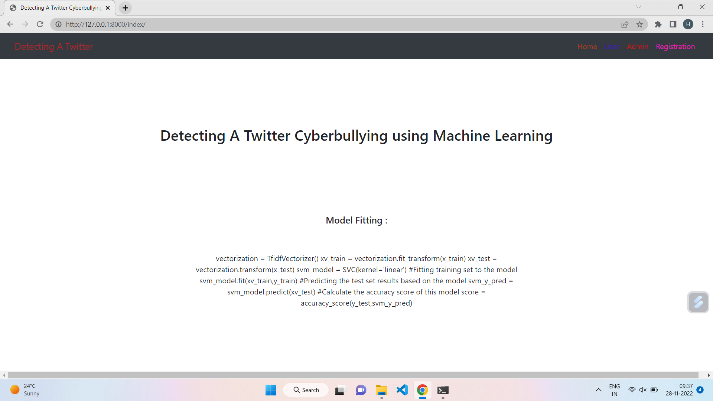

User register:

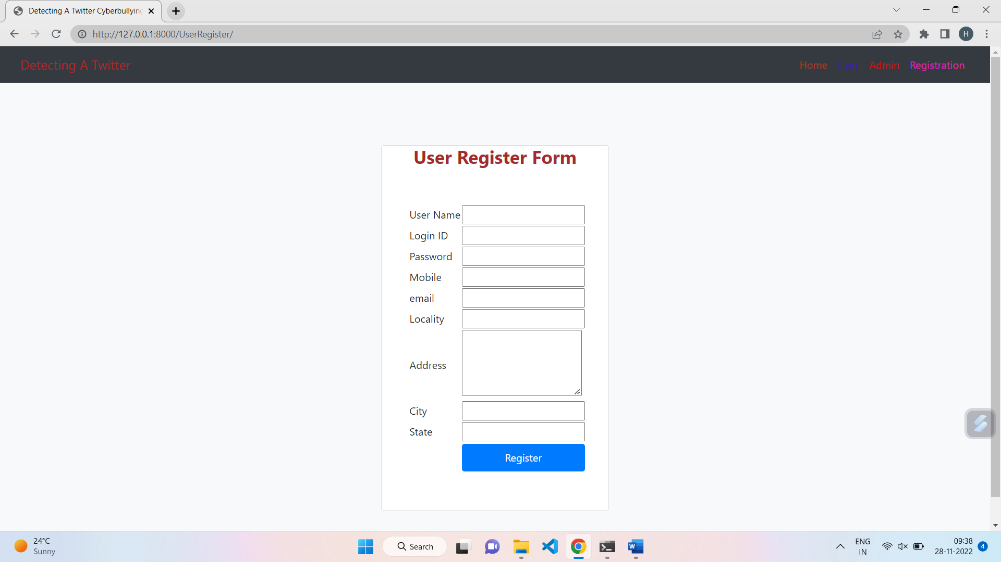

Admin login:

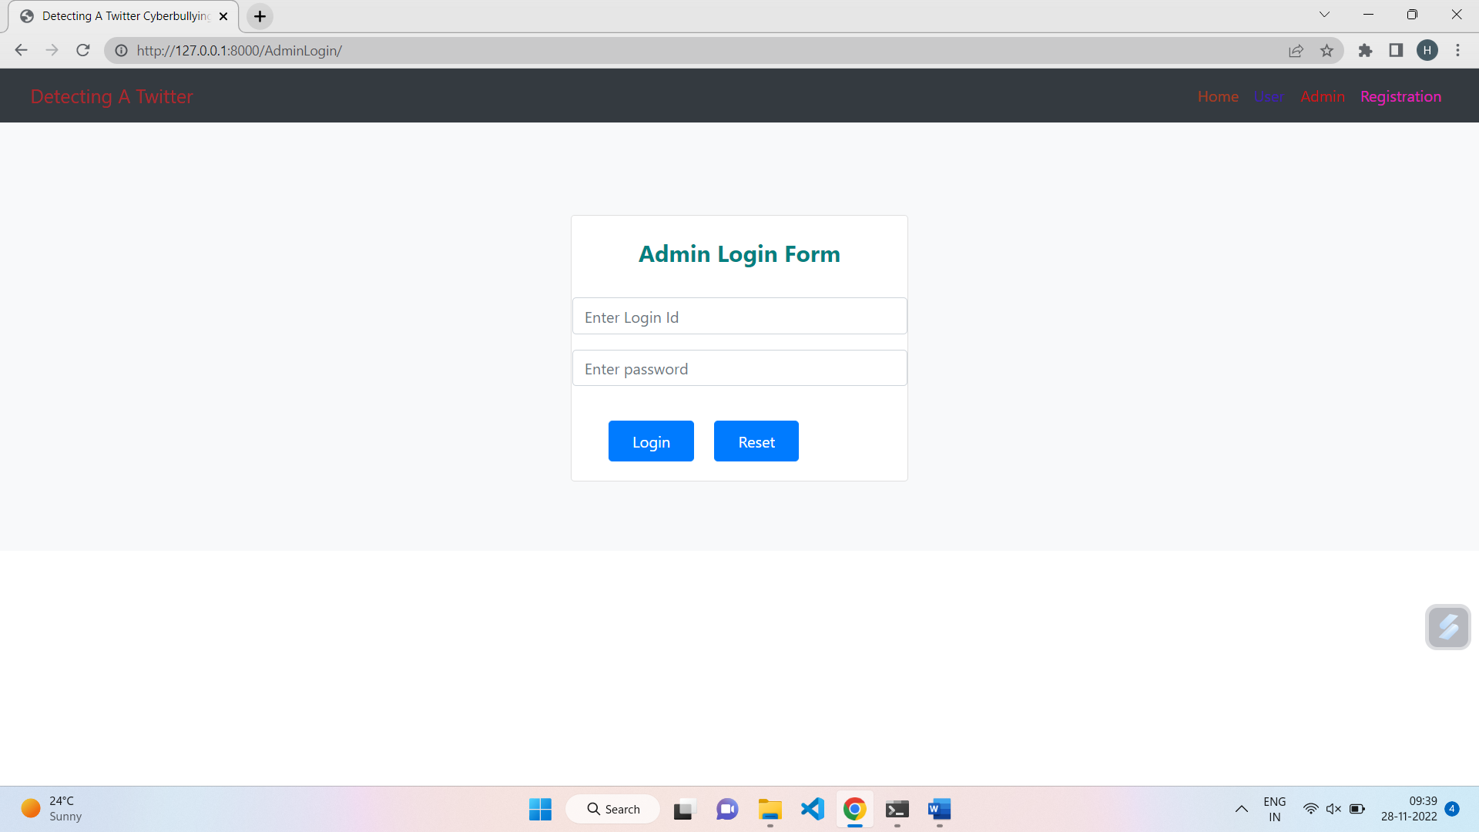

Admin home:

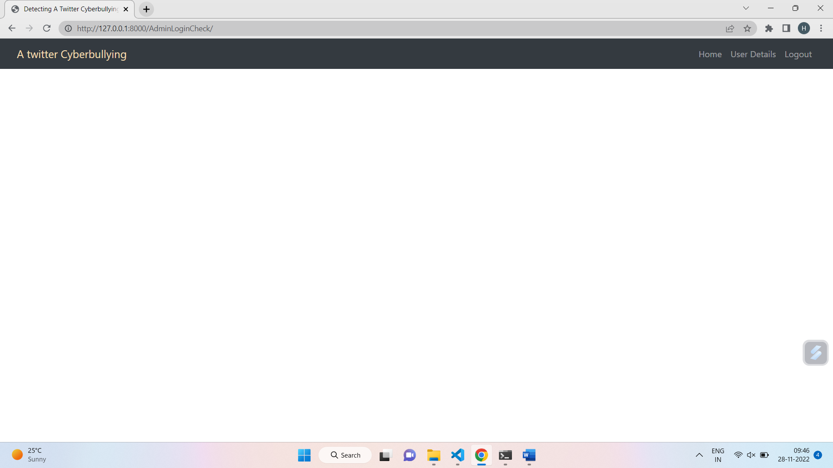

User details:

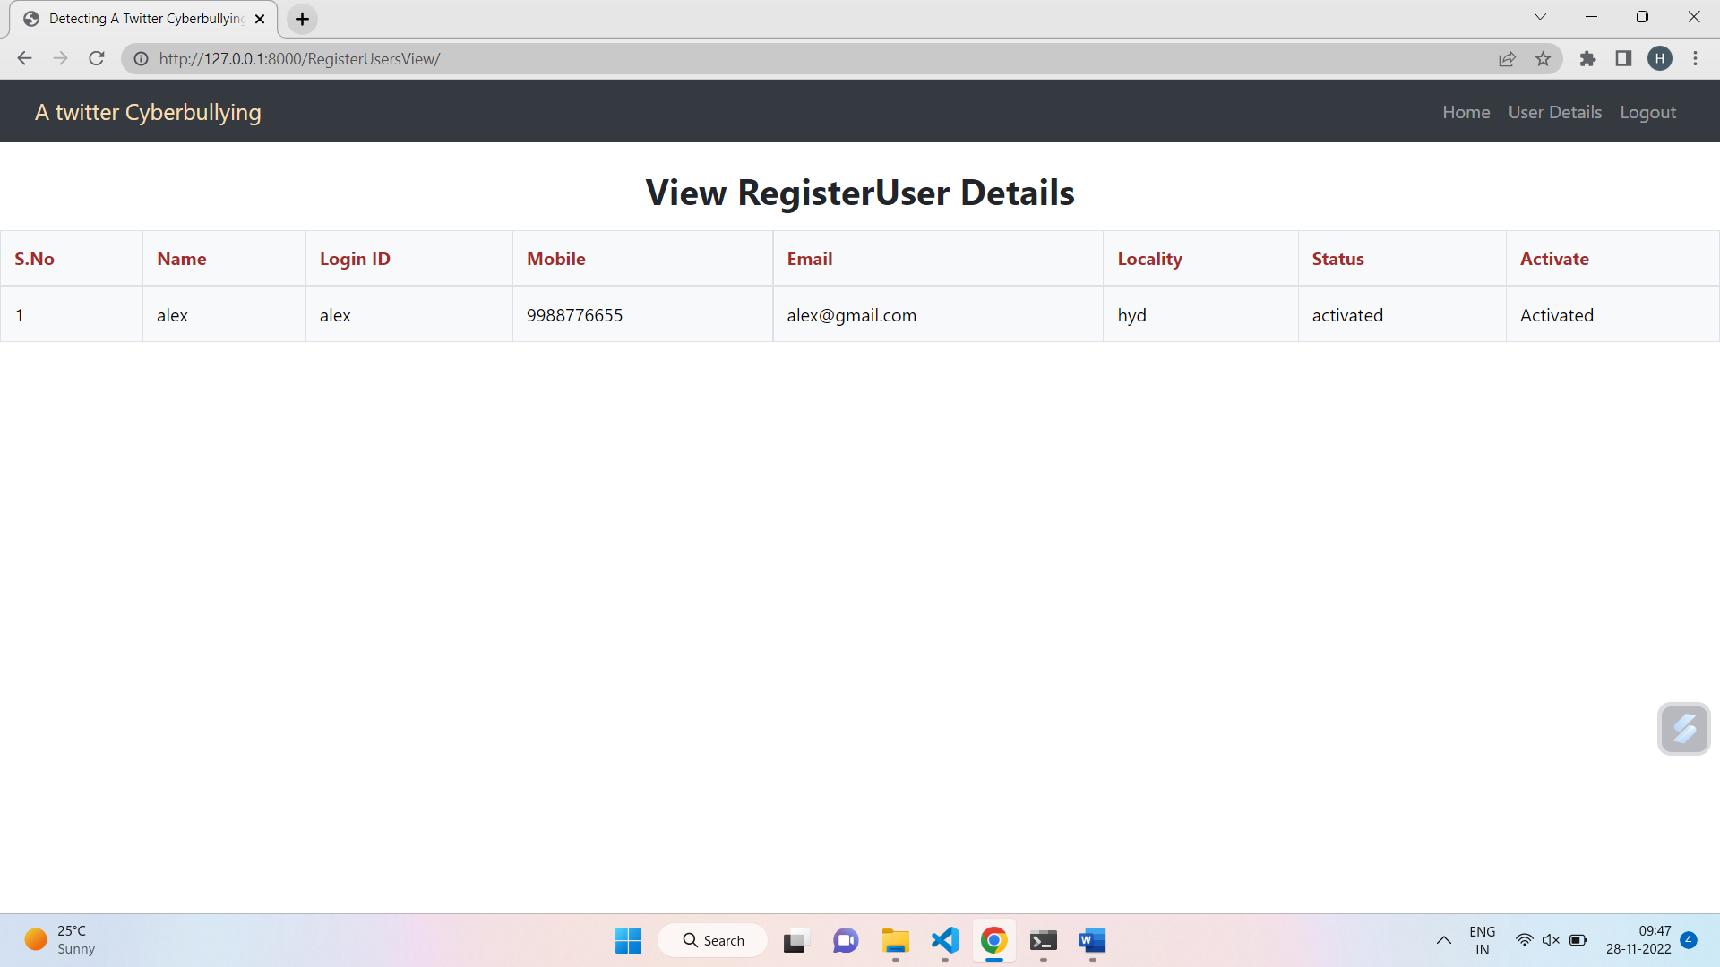

User login:

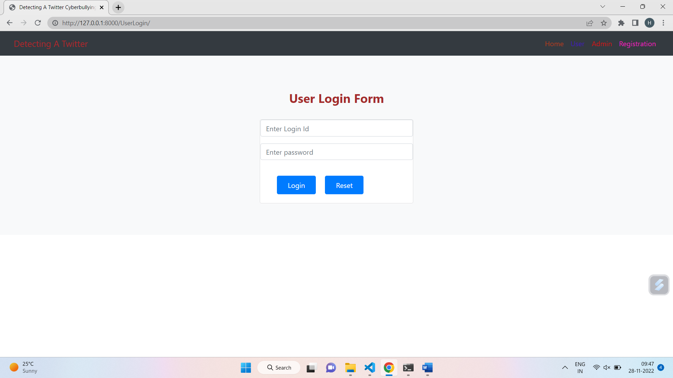

User home:

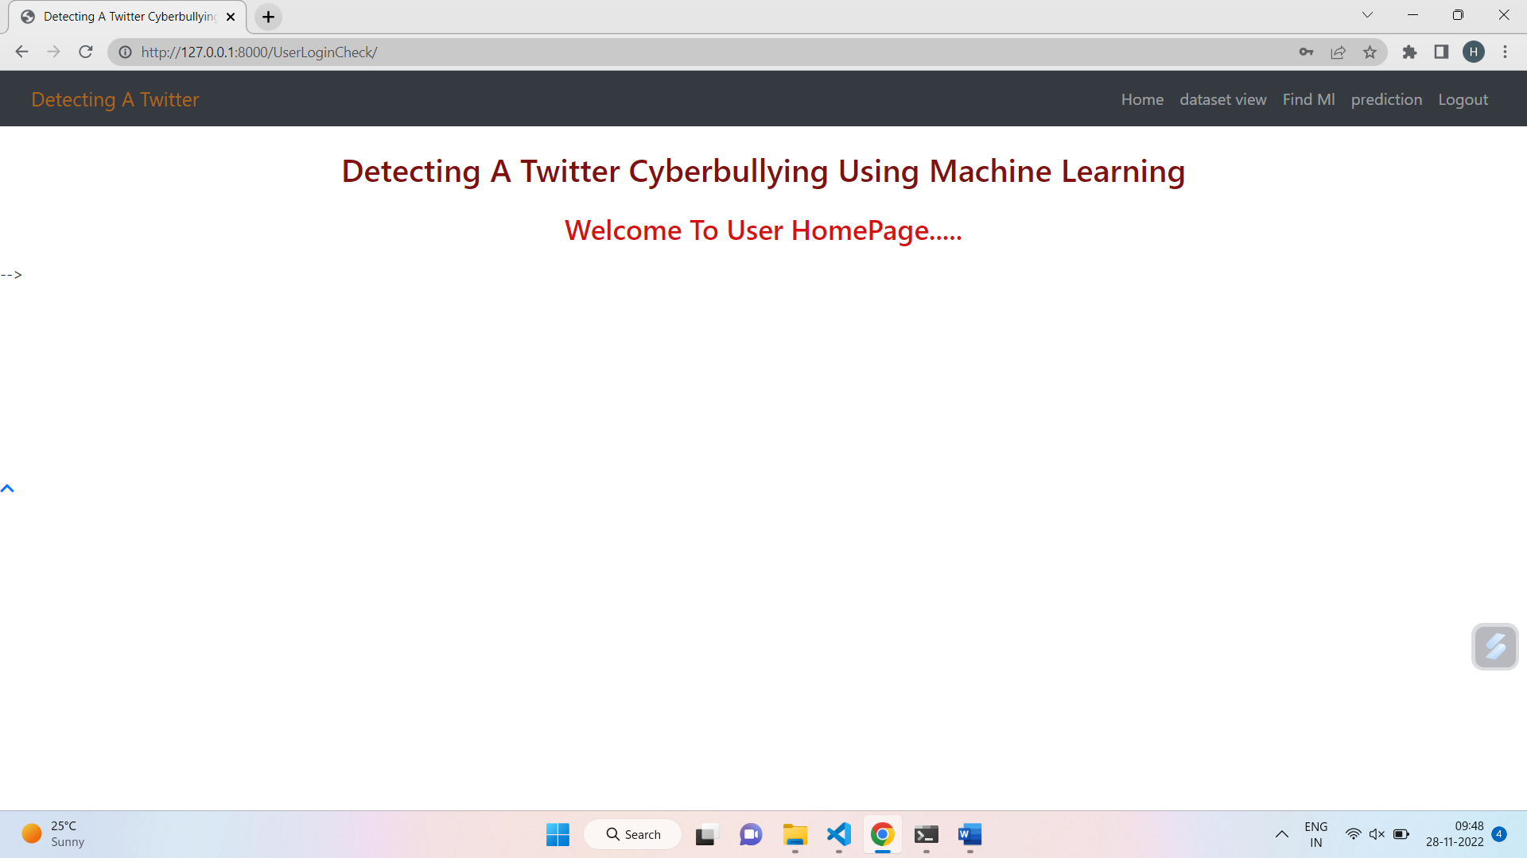

View dataset:

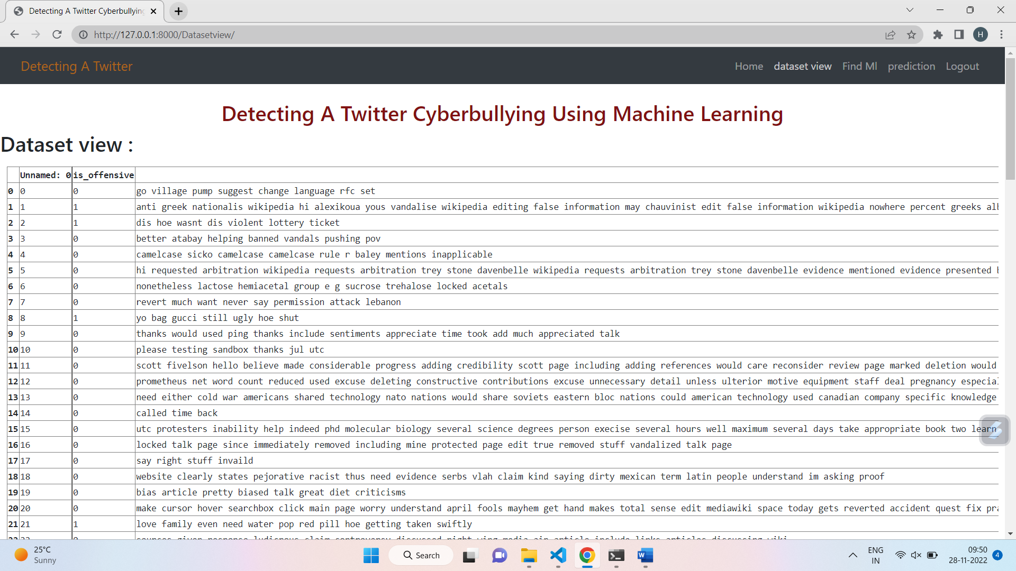

Ml results:

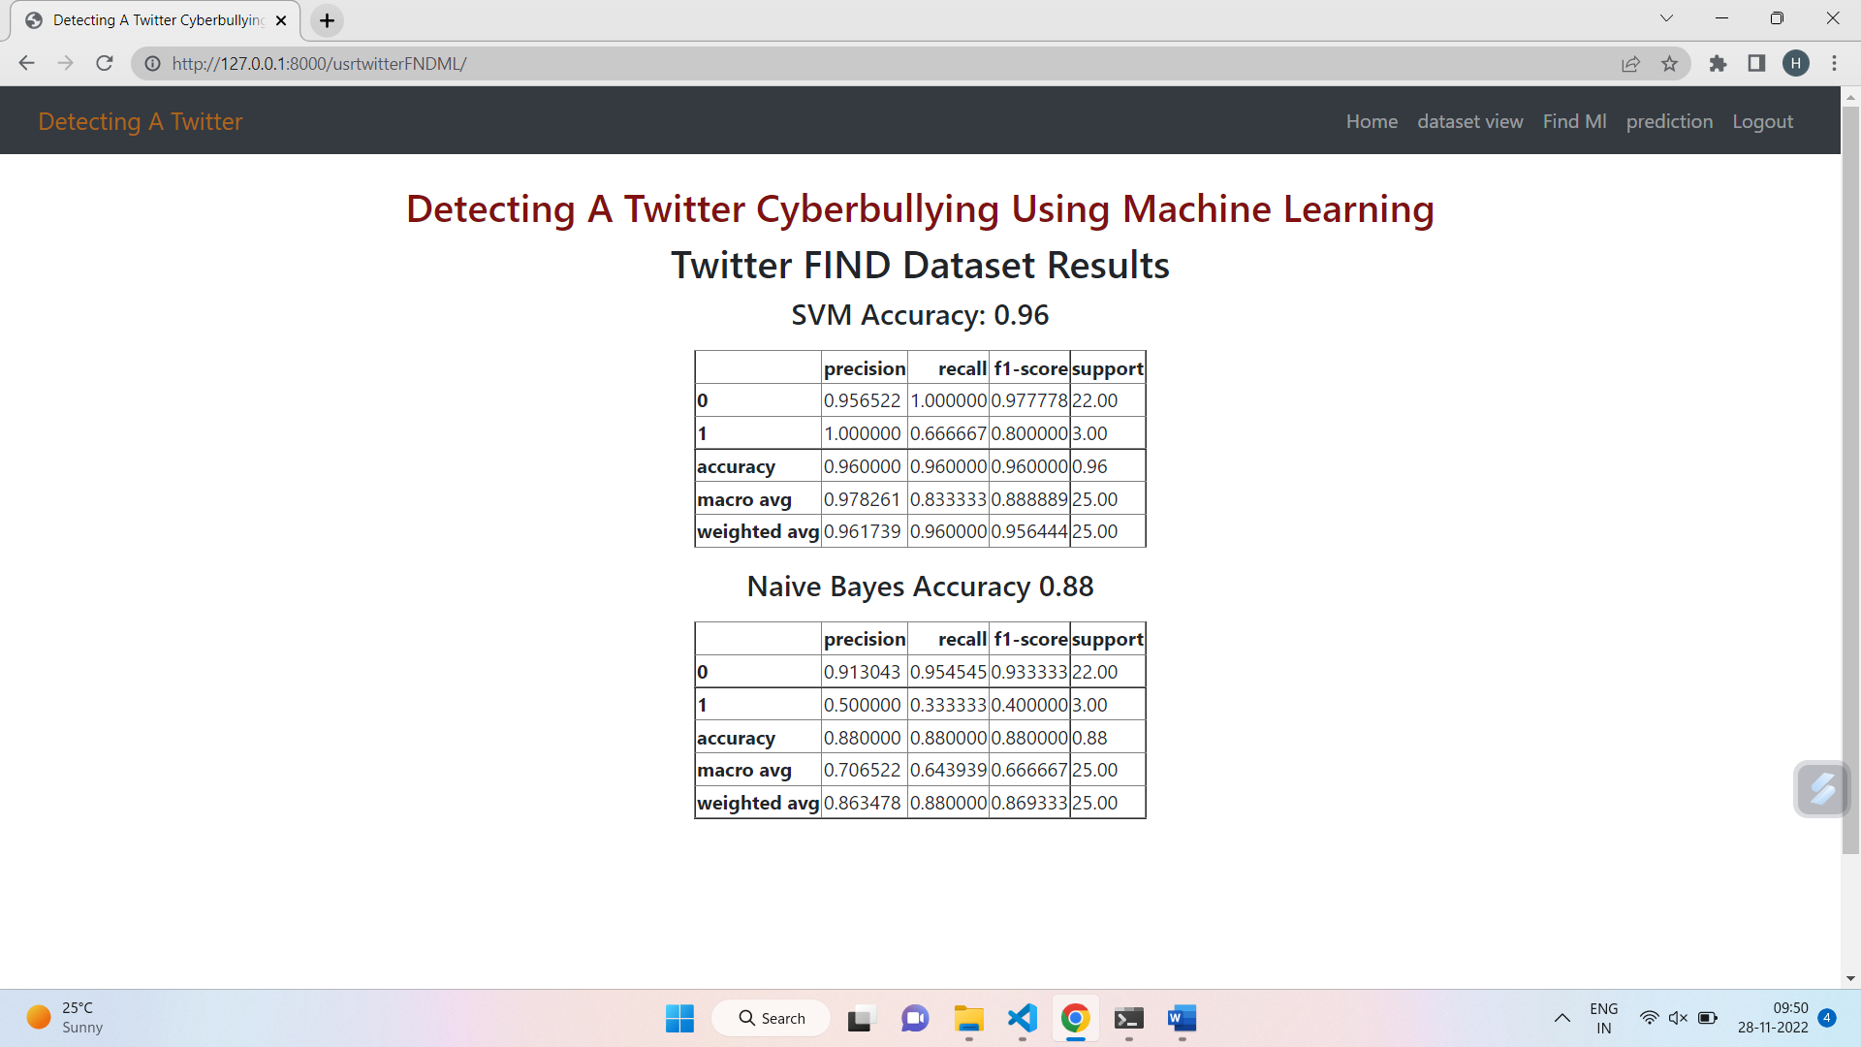

Predict results true:

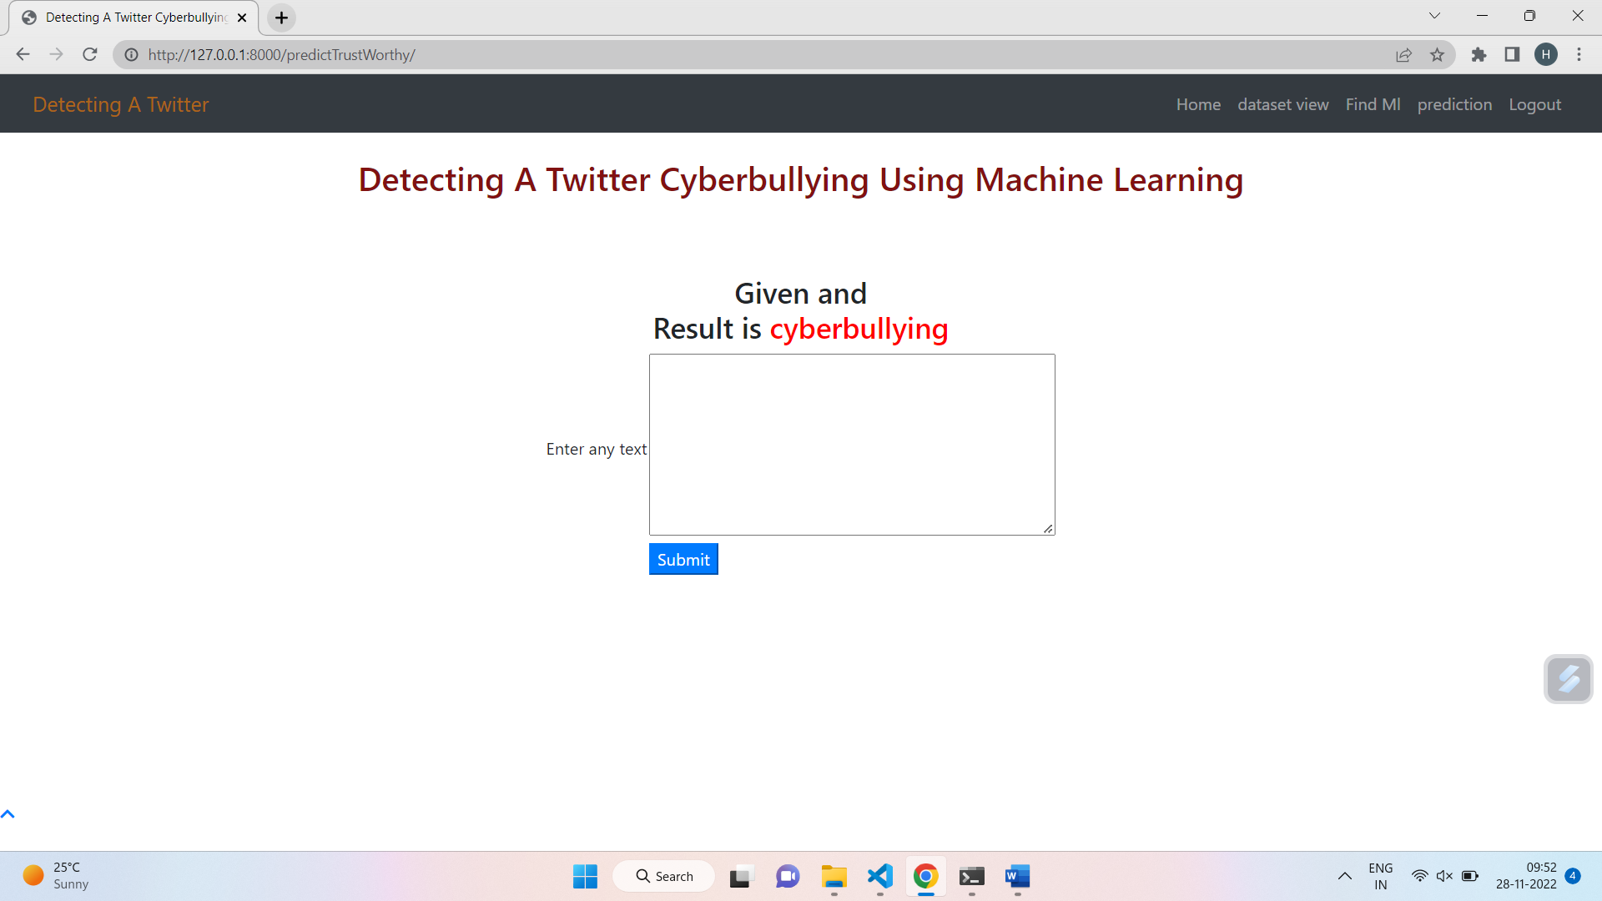

Results false:

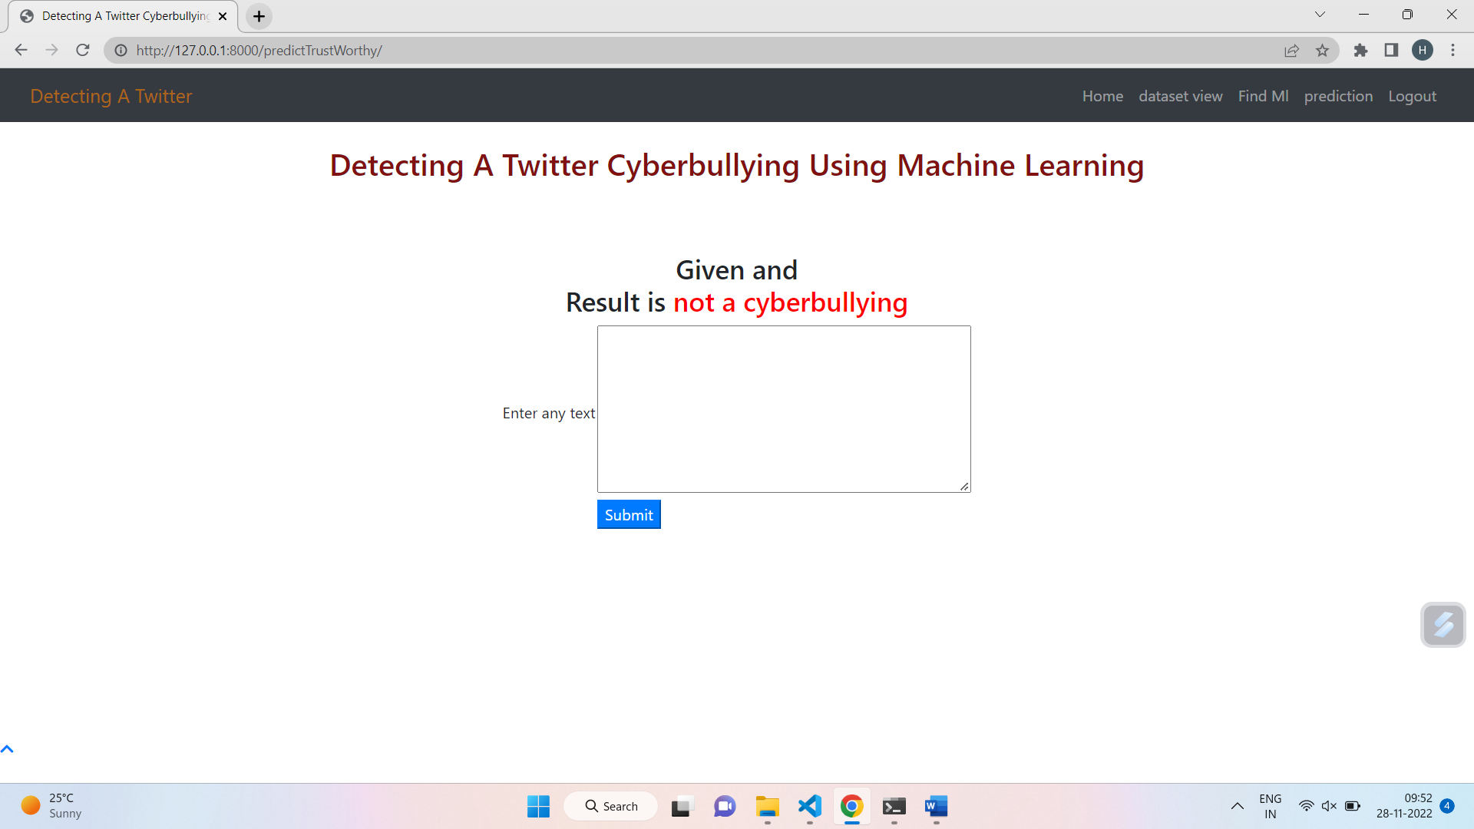

**REFERENCES**

[1] John Hani Mounir, Mohamed Nashaat, Mostafa Ahmed, Zeyad Emad, Eslam Amer, Ammar Mohammed, “Social Media Cyberbullying Detection using Machine Learning”, (IJACSA) International Journal of Advanced Computer Science and Applications Vol. 10, pages 703-707, 2019.

[2] Kelly Reynolds, April Kontostathis, Lynne Edwards, "Using Machine Learning to Detect Cyberbullying”, 2011 10th International Conference on Machine Learning and Applications volume 2, pages 241–244. IEEE, 2011

[3] Amanpreet Singh, Maninder Kaur, "Content-based Cybercrime Detection: A Concise Review”, International Journal of Innovative Technology and Exploring Engineering (IJITEE) ISSN: 2278-3075, Volume-8 Issue-8, pages 1193-1207, 2019

[4] Abdhullah-Al-Mamun, Shahin Akhter, "Social media bullying detection using machine learning on Bangla text”, 10th International Conference on Electrical and Computer Engineering, pages 385-388, IEEE Xplore, 2018

[5]NektariaPotha and ManolisMaragoudakis. “Cyberbullying detectionusing time series modeling”, In 2014IEEE International Conference on, pages 373– 382. IEEE, 2014.

[6] Ying Chen, Yilu Zhou, Sencun Zhu, and Heng Xu. “Detecting offensive language in social media to protect adolescent online safety”. In Privacy, Security, Risk and Trust (PASSAT), 2012 International Conference on and 2012 International Conference on Social Computing (SocialCom), pages 71– 80. IEEE, 2012

[7] Vikas S Chavan, SS Shylaja. “Machine learning approach for detection of cyber-aggressive comments by peers on social media network". In Advances in computing, communications, and informatics (ICACCI), 2015 International Conference on, pages 2354–2358. IEEE,2015

[8] Walisa Romsaiyud, Kodchakorn na Nakornphanom, Pimpaka Prasertsilp, Piyaporn Nurarak, and Pirom Konglerd, “Automated cyberbullying detection using clustering appearance patterns”, In Knowledge and Smart Technology (KST), 2017 9th International Conference on, pages 242– 247. IEEE, 2017

[9] <https://muthu.co/understanding-the-classification-report-in-sklearn/>

[10] <https://developer.twitter.com/en/apps>

[11] <https://text-processing.com/demo/tokenize/>

[12] <https://towardsdatascience.com/support-vector-machine-introduction-tomachine-learning-algorithms-934a444fca47>

[13] https://towardsdatascience.com/naive-bayes-classifier-81d512f50a7c

**CONCLUSION**

An approach is proposed for detecting and preventing Twitter cyberbullying using Supervised Binary classification Machine Learning algorithms. Our model is evaluated on both Support Vector Machine and Naive Bayes, also for feature extraction, used the TFIDF vectorizer. As the results show us that the accuracy for detecting cyberbullying content has also been great for Support Vector Machine of around 71.25% which is better than Naive Bayes. Our model will help people from the attacks of social media bullies.

**FUTURE ENHANCEMENT:**

further research on this topic to improve and design better models to improve accuracy and generate reviews.